Chapter 6, Problem 45.

If the voltage waveform in Fig. 6.68 is applied to a 10-mH inductor, find the inductor current i(t). Assume i(0) = 0.

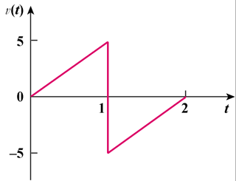

Figure 6.68
For Prob. 6.45.

